Malcom X

Background information:

He was criticizing the movement of Martin Luther King, because he didn’t pay attention to the people in the north regions. Malcolm, who grew up in this region where he was known as “Detroit Red “engaged for his people. He thought that the peaceful approach of Martin Luther King was just begging for justice again. The white people were always violent against black people and Malcolm said that the black people should start “speaking their language” and be violent too.

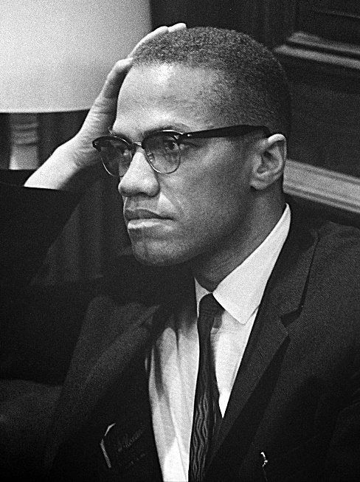

-human rights activist

-lived in alike neighborhoods

-experience of racial segregation

-controversy (different style, clothing)

Mentioned by:

-Starr: she mentions the poster that is hung up in their home

Significance for the characters in the book:

-Nana doesn’t like the picture

-Carlos hung it on the wall